**All possible User Personas**

1. Active Job seeker
2. Passive Job seeker
3. Professional Networker
4. Individual Recruiter
5. Corporate Recruiter
6. Corporates looking for recruiting solutions
7. Corporates looking for marketing solutions
8. Other (Students, Non profits, government, political orgs ...etc)

**Key Personas**

1. Active Job Seeker
2. Individual/Corporate Recruiter

**User Persona Description**

**Professional Networker - Jane**

Goal : Maximise the online connections for future leverage

Motivation: The need to connect socially and be connected to the groups.

Tasks/Activities: Lookup and connects with people, Interested in following industry trends and connecting with people and groups. Actively creates content, posts and follows other posts on LinkedIn.

Other Attributes: Is very outgoing, social and is very involved in making connections.

**Active Job Seeker - Bob**

Goal: Connect to recruiter/interviewer to with the goal of landing the job

Motivation: Immediate need of a job.

Tasks/Activities: Needs to create and maintain and impressive profile.Needs to see the jobs posted every day and apply regularly. Keep the profile and connections up to date. Reach out to recruiters. Reach out to contacts in companies of interest.

Other Attributes: Is probably the most active user in LinkedIN. Needs a job and is pulling all strings to land a job. Most likely candidate for the premium account “Job seeker”

**Passive Job Seeker - Carol**

Goal: Passively looking, will consider really good job opportunites that come his/her way

Motivation: Keep an up to date profile and be connected to get to their dream job in the future.

Activities: Stay current on the industry trends. Keep updated Profile and make connections. Involved in groups. Respond to any recruiter messages. Lookup and follow influencers in the industry.

Other Attributes:

**Individual/Corporate Recruiter - Amit**

Goal: Get the right candidate for the job.

Motivation: Gets paid when a candidate they found gets the job offer. Help in doing their work.

Activities: Post Jobs with right job description. Filter candidates based on skillsets that match job description. Look at the responses received to the job posting and pick the right candidate for the interview.Usually are pressed for time as they are dealing with number of responses every day.

**Corporates - Groupon**

Goal: Need a recruiting solution that takes care of all stages of the hiring process, from posting, filtering the right candidate, interviewing, decision making to final offer.

Motivation: One stop shop for all the firms hiring needs. Find for the right candidate for the role in the shortest possible time.

Activities: Buys job slots for the company recruiters to post jobs.Post Jobs, Store all responses, Filter to find the best candidates for the jobs, call for interviews, shortlist candidates and then offer.

Uses the linkedin platform for internal company referrals. Lookup the candidates credentials. Might want to check the credibility from the candidate profile..

**Survey Design**

Goal of the survey : to capture the most used features

Survey Questions: https://www.surveymonkey.com/r/G6YVB8M

**Results and Analysis**

**Most used feature**

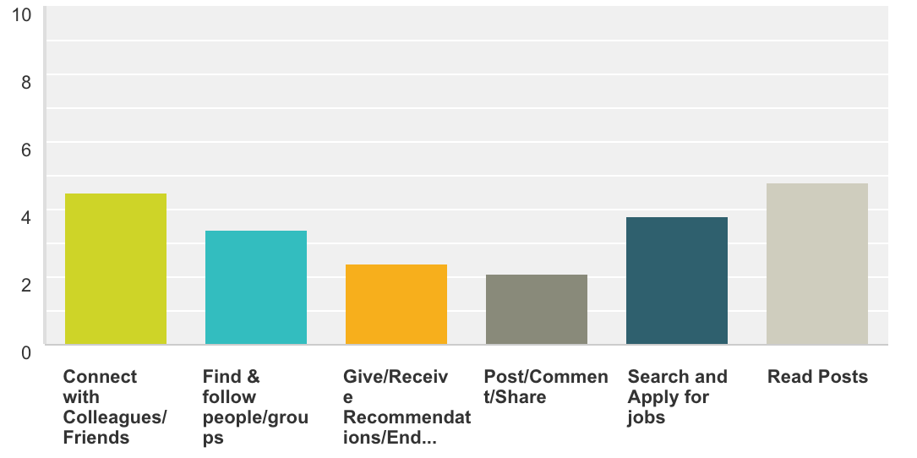

# 

# 

# 

# **Which of the following features would you be willing to pay for? (Select all that apply.)**

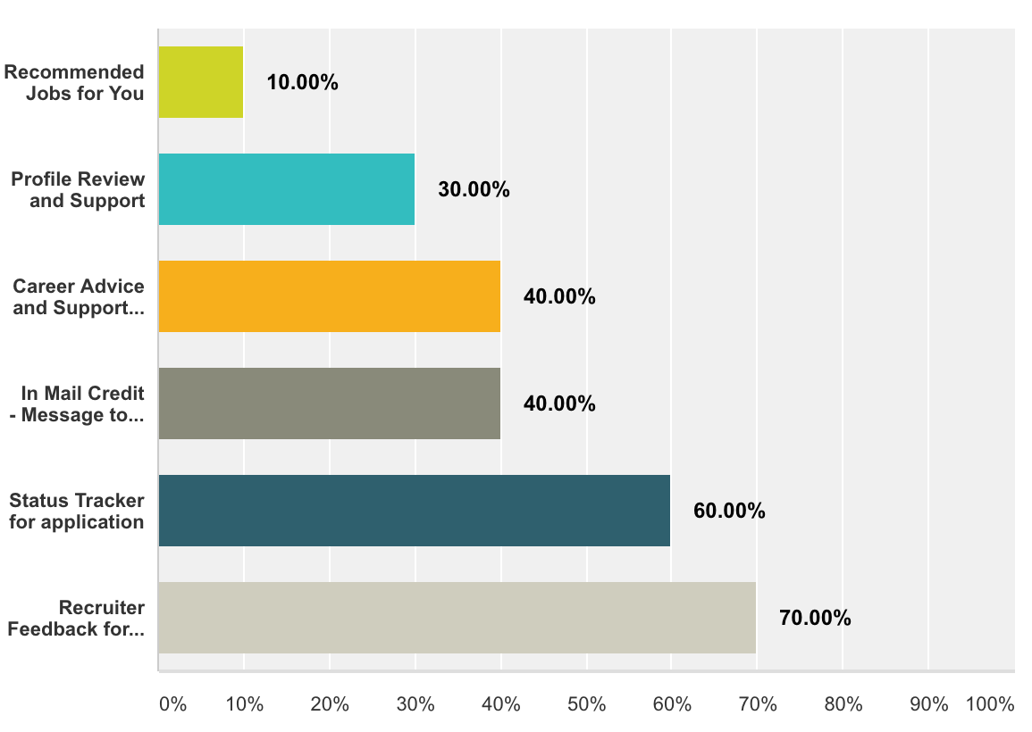

**Customer Satisfaction amongst Premium Account Members**

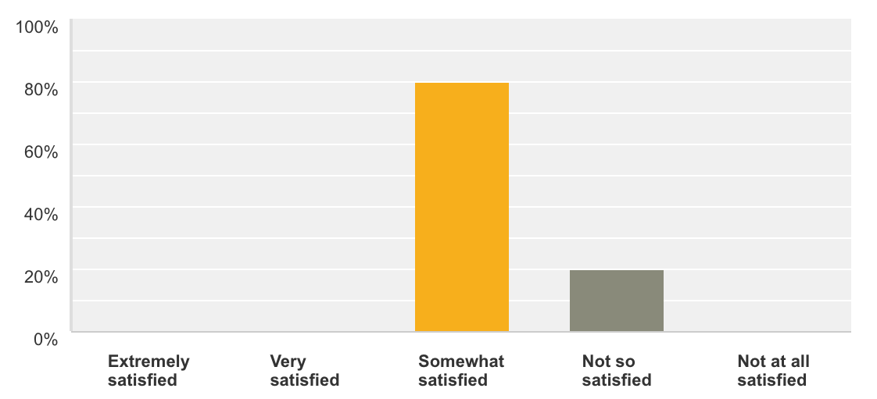

**User Interviews**

Goal of the interview : To find out what are the features expected by a job seeker while using LinkedIN and can LinkedIN become the complete recruitment platform for recruiters and jobseekers.

Questions for the interview :

Q1: How often do you login to LinkedIn?

Q2: Could you describe some of the tasks that you do often on LinkedIn?

Q3: What are some of the features that you like ?

Q4: What are the some of the aspects of LinkedIn that is not very appealing to you improve?

Q5: What’s the main benefit that you derive from Linkedin ?

Q6: How has your LinkedIN network helped you?

Q7: What are the problems you encounter often on LinkedIn ?

Q8: How do you think LinkedIn can help you with you career development ?

Q9: What are some other features that you would like to see in LinkedIn

Q10: What other Job sites do you use for your job search and why ?

**User Interview 1**

User Profile : Active Job seeker, premium member

Q1: How often do you login to LinkedIn? -- couple of days/week

Q2: Could you describe some of the tasks that you do often on LinkedIn?

Look at News Feed, posts from the network and Groups. Search for jobs,look at profiles. But applies for the job directly from the company website. Used to apply from LinkedIN but not any more

Q3: What are some of the features that you like

The job filter that lets you search for jobs by a ton of criteria like title,company, salary, location, job function etc., and also shows the connections in my network who are working with the company currently. Also the notification alerts that tell me when a saved job is expiring.

Q4: What are the areas where you think LinkedIn can improve?

What stage application process is my application in like jobvite. There is no feedback mechanism. It would help if I can see which stage of the hiring process my application is in.

Q5: What’s the main benefit that you derive from Linkedin -- Manage all professional contacts in one location ..LinkedIn contacts .. maintain online contacts. And when not necessarily ..

Q6. Could you describe how the LinkedIN network helped you in your job search ?

Got introduced to a second degree connection for a job that I was interested in and could understand the company and the posting. Also I can looking up the profile of the interviewer to understand them before the interview

Q7 What do you think about the Premium account :-

Premium account is expensive .. don’t get the benefits .. 10 $ a month would be a good price point for the existing job seeker account.